Economic Inequality and Ethnic Nationalism: A Comparative Examination of Russia and China

Madison E. Perry

Old Dominion University

Introduction

Ethno-nationalism (or ethnic nationalism) can be defined as an ideology “in which identity is defined by perceived genetic, religious or linguistic heritage rather than democratic ideals or principles” (Shiller, 2016). While nationalism is classically defined as “pride in one’s people and the belief that they have their own political sovereignty separate from others’ ” (O’Neil, 2018), it can also accompany aspirations for separate statehood and/or tension with out-groups.

By emphasizing ethnic characteristics above civic characteristics as the basis for a national identity, ethnic nationalism is thought by some to increase likelihood of race-based conflict, as ethno-nationalists advocate for their group’s political sovereignty especially to the “exclusion or detriment of the interests of other groups” (Shiller, 2016). Ethnic nationalism can connect individuals to a larger sense of pride, achievement and history, but also can allow for resurgence of “hostility to non-group members, chauvinism, and racism” (Drobizheva, 1997).

While Russia and China have very different ethnic groups and have pursued different economic/political transitions in the wake of their respective authoritarian regimes, both are moving towards capitalistic economic policies and have experienced upticks in ethno-nationalism. Comparative analysis of these two states can help us begin to understand the relationship between ethno-nationalist sentiments and economic inequality.

Validity of Comparison

Russia and China are ripe for comparative analysis primarily due to their historical similarities. Both entities are geographically large, at 6.6 and 3.7 million mi^2 respectively (World Bank, 2019), though China’s population has continued to grow to heights of 1.4 billion people, while Russia’s holds steady at approximately 144.5 million people (World Bank, 2019).

Most salient to this comparison, both states experienced major revolutions in the 20th century and have recent experience with authoritarian communist rule (Lenin and Stalin in Russia, Mao in China). Currently, both states are engaged in transitions from centrally planned economies towards versions of free-market capitalism and are achieving varying levels of success. In this paper, I will examine the similarities and differences of their respective transitional policies alongside changing attitudes about ethnicity and national identity.

Russia’s Economy

Upon the collapse of the USSR, the Russian government rapidly moved to privatize all of the industries previously under state control. All state assets were auctioned off and acquired by a small group of wealthy tycoons, effectively creating what experts refer to as the oligarch class. Some scholars viewed these oligarchs as change agents and potential opponents of the “predatory and corrupt” (Guriev et al., 2005) Russian bureaucracy with the ability to restructure Russian industries through their investments amidst an otherwise hostile business environment (ibid).

However, the oligarchs overwhelmingly chose to concentrate their capital investment in Russia’s industrial sector. Given the profitability of oil, gas, and other natural resources, entrepreneurs have “insufficient incentive to renovate” (Kurkchiyan, 2017) other, less lucrative branches of the economy, creating the homogenous and extractive resource-based economic model upon which modern Russia operates.

In its effort to switch over to liberal economic policies as quickly as possible following the fall of the USSR, the Russian government also rapidly lifted price controls and instituted austere cuts to public spending. These policies resulted in massive inflation, sharp decreases in consumption spending, and one of “the most severe and long-lasting economic decline(s)” in modern history, spanning 1991-1998 (Kotz, 2005). Since 1999, the Russian economy has been expanding, but dominant shares of this growth is due to favorable conditions in the world market for oil. Only approximately 1% of the Russian labor force is employed in the oil and gas sectors (World Bank, 2019) and under the new system, Russia’s oil resources are now being sold as exports, “enrich(ing) the small group that gained control” (Kotz, 2005) rather than promoting beneficial economy-wide growth.

In its rapid transition to liberal economic policies, Russia has seen a massive uptick in economic inequality, as the wealthy oligarch class profits from exporting natural resources, while 55% of Russian households have been “thrust backward” (Kotz, 2005) with only enough to spend on bare subsistence (ibid). The relative impoverishment of the working class proves especially demoralizing given the urbanized and well-educated status of Russia’s population, creating fertile ground for reactionary movements. The following chart illustrates the uptick in inequality from 1990 onward:

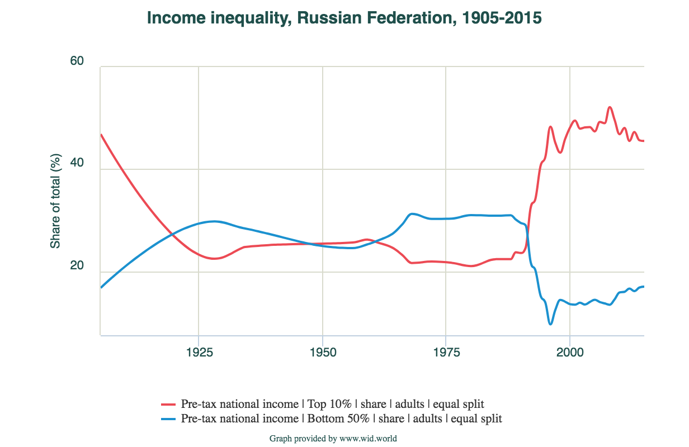

China’s Economy

China began its transition toward a market economy in 1978, gradually adopting policies of privatization and lifting price controls, but because of this graduality it did not immediately face a sharp recession like Russia did. While China’s economy has exhibited more stable growth over a longer period, like Russia it is heavily reliant on maintaining high ratios of exports to GDP in order to keep growing (Kotz, 2005).

Increasing its Gini coefficient 15 points since 1990 (IMF 2018), China’s levels of income inequality have skyrocketed, holding consumer demand down even more and driving the economy’s vicious cycle of export reliance. With the largest sector of the Chinese economy being manufacturing at 44% of total GDP (World Bank, 2018), the majority of the population earns very low wages relative to those of the industry tycoons. Income inequality continues to grow, with the top 1% earning the same fraction of net national income as the bottom 50% combined (World Inequality Database, 2015). China’s rising economic disparity is most clearly illustrated by the following graphic from the World Inequality Database:

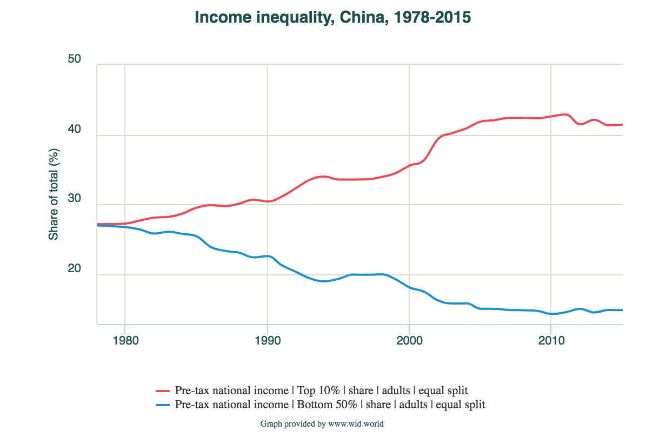

Ethno-nationalism in Russia

During the mid-1970s, surveyors found that the vast majority of interethnic attitudes within the Soviet Union were either neutral or favorable. Some experts posit that this phenomenon was due in part to the economic and social practices of the Communist government. Policies of Soviet affirmative action led to “nationally minded intelligentias” (Drobizheva, 1997) and helped created a kind of “imperial mass consciousness” (ibid). With the collapse of the Soviet Union and the termination of the aforementioned unifying policies, scholars observed a rise in anti-Russian sentiments among other ethnic groups and hostility among ethnic Russians towards people from Caucasus and Central Asia.

As economic inequality has continued to grow, Russia has seen a resurgence of reactionary groups like the “Pamyat” (translated: “Memory”) and offshoots who have stoked flames of chauvinism and anti-Semitism, suggesting that women, Jews, and ethnic minorities are to blame for Russia’s problems. Survey data reflects that in 1993, approximately one-third of Russians strongly believed that non-Russians residing in Russia were the cause of economic ills and 53% of Russians indicated that ethnic Russians should have more rights than non-Russians (Drobizheva, 1997).

Most recently, Vladimir Putin has harnessed latent ethno-nationalist sentiments to justify aspects of his agenda for Russia, most notably his 2014 invasion and annexation of Crimea under the guise of “protecting ethnic Russians”. Connections between ethno-nationalism and the adoption of interventionist policies make this topic relevant in both spheres of comparative politics and international relations.

Ethno-nationalism in China

There are officially 56 ethnic groups in China, and of its 1.2 billion people, more than 95% are identified as ethnically Han(Cheng, 2014)*.* According to Chinese anthropologists, today’s Chinese ethno-nationalism “exploits nativist ancestral claims back to antiquity” (Yen, 2012) in order to legitimize the geo-political occupation of the entire territory of modern China, including many areas where non-Han people historically have lived.

Recent research reveals that work-force segregation and educational disparities between minorities and those of Han ethnicity have increased over time from 1982 to 2005 (Wu, et al, 2014). Since the early 1950s, China’s communist government identified non-Han minorities and implemented various policies to “protect their socioeconomic rights and to promote ethnic egalitarianism and national unity” (ibid), but throughout China’s transition to state capitalism, profit-seeking firms have logically prioritized economic efficiency over social justice, leading to increased labor market discrimination, particularly in the urban sectors which have seen the most growth (ibid).

Though China’s economic disparities statistically favor Han Chinese over minority groups, all working class Chinese are impacted negatively by the increased consolidation of wealth among the top 1% of Chinese households (Sullivan, 2013). In response to this decrease in general economic well-being, many disaffected Chinese have been drawn to reactionary groups which romanticize “old ways of life” (Carrico, 2017) and the “glorious past of the Great Han” (ibid).

One such group is the Han Clothing Movement, which first came to prominence in 2001 as a response to modern China’s “society of capitalism, corruption,… and binge-drinking youth” (Carrico, 2017). This movement regards Western influences and non-Han minorities, particularly the Manchus, as the dominant corrupting forces in present-day China. The Han Clothing Movement has been growing in popularity and has been characterized as “racist, sexist, and patronizing” (ibid); a cause for concern regarding China’s future political directions as President Xi Jinping has seemingly alluded to ethno-nationalism by calling for the realization of his “Chinese Dream” which would consist of the “great rejuvenation of the Chinese nation/race” (Carrico, 2017).

Discussion

Though China is widely regarded to have made a much more successful post-communist transition, we can observe marked increases in income and wealth inequality in both Russia and China. In both countries, these deepening disparities are accompanied by resurgence in groups that engage in the scapegoating of ethnic out-groups and seek to return to a romanticized past. Economic downturns are historically associated with rising tensions along ethnic lines (see Great Depression and Germany pre-WWII), so it follows that the inherent rising inequality that accompanies the adoption of neoliberal economic policies would correlate with rising ethno-nationalist sentiments in post-communist states.

Further research is needed to empirically assess the relationship between rising inequality and ethno-nationalism. These preliminary observations seem to confirm certain accepted truths about the conflict between maximizing freedom and maximizing equality. Liberal economic policies promote growth at the price of greater inequality and are touted as maximizing individual economic freedom, while command economies promote equality at the price of inefficiency and are often associated with other forms of political repression. One might question whether a rise in ethnic nationalism and racial tension is the price states pay for pursuing growth at any cost, but economist Robert J. Shiller asserts that rising inequality and “considerable fear of inequality” (Shiller, 2016) can account for the evident rise in ethnic nationalism, particularly if combined with a global slowdown in economic growth, perhaps making growth a double edged sword with regard to ethnic tensions.

Carrico, Kevin. (2017). *The Great Han: Race, Nationalism, and Tradition in China Today.* University of California Press. Accessed April 11, 2019, at <https://sentinel.tw/racial-thinking-modern-china/>

Kurkchiyant, Marina. (2008). “Russia and China: A Comparative Perspective on the Post-communist Transition." Rule of Law in China: *Chinese Law and Business.* Edited by Phil Dines. The Foundation for Law Justice and Society. Accessed April 10, 2018 at <https://www.academia.edu/1328569/Russia_and_China_a_Comparative_Perspective_on_the_Post-Communist_Transition>

Cheng, Hsin-I. (2014). “In the Eyes of the Chinese: Affective Construction of Cultural Identity”. Doctoral Dissertation. Santa Clara University. Accessed April 11, 2019, at <https://www.immi.se/intercultural/nr35/cheng.html>

Drobizheva, L. (1997). “Russian Ethnonationalism”. Doctoral Dissertation. Dartmouth University. Accessed April 12, 2019, at <http://www.dartmouth.edu/~crn/crn_papers/Drobizheva1.pdf>

Jain-Chandra, Sonali. Khor, Niny. Mano, Rui. Schauer, Johanna. Wingender, Philippe. Zhuang, Juzhong. (2018). “Inequality in China – Trends, Drivers and Policy Remedies”. Asia and Pacific Department. IMF Working Paper. International Monetary Fund. Accessed April 12, 2019 from IMF Archives.

Kotz, David M. (2005). “The Role of the State in Economic Transformation: Comparing the Transition Experiences of Russia and China”. University of Massachusetts Amherst. Accessed April 14, 2019 at <https://scholarworks.umass.edu/cgi/viewcontent.cgi?article=1064&context=econ_workingpaper>

O’Neil, Patrick H. (2017) “Nationalism”. *Essentials of Comparative Politics.* Sixth Edition. Published by W. W. Norton and Company.

Shiller, R. J. (2016). “What's Behind a Rise in Ethnic Nationalism? Maybe the Economy.” New York Times. Accessed April 10, 2019, at <https://www.nytimes.com/2016/10/16/upshot/whats-behind-a-rise-in-ethnic-nationalism-maybe-the-economy.html>

Sullivan, C. B. (2013). “Ethnic Inequality in China: Structural Violence, Educational Stratification, and the Rural Household Income Gap”. Doctoral Dissertation. University of California, Berkeley. Accessed April 15, 2019 from UC Berkeley Archives (pdf version).

Yen, Hsiao-pei. (2012). “Constructing the Chinese: Paleoanthropology and Anthropology in the Chinese Frontier, 1920-1950”. Doctoral dissertation, Harvard University. Accessed April 11, 2019 at <https://dash.harvard.edu/handle/1/10086027>

World Inequality Database. (2019). Accessed April 14, 2019 at <https://wid.world/>

Wu, Xiaogang. Song, Xi. (2013). “Ethnicity, Migration, and Social Stratification in China”. Population Studies Center. University of Michigan Institute for Social Research. Accessed April 14, 2019 at <https://www.psc.isr.umich.edu/pubs/pdf/rr13-810.pdf>